FTM-350R expand frequency modification

Yaesu typically doesn't release the extended transmit mod information until a couple of months after the radio has been out, but I really do need this because of my Navy MARS involvement. After studying the schematic and board for a few hours and looking at other recent Yaesu radio mods, I figured out the mod for the FTM-350r.
Here is the extended transmit mod for the Yaesu FTM-350r:
- Make sure everything is disconnected from the radio. This includes the power, control head, mic, coax, speakers, and anything else you have connected.
- Open the main radio chassis, removing the four allen machine screws and lock washers. The allen wrench is provided in the package. Disconnect the speaker from the main board by simply unplugging it.
- With the cover removed orient the radio so that the control cable and mic RJ-45 connectors are facing you. When you do this, the main processor will be toward your left.
Locate a series of 3 resistors that are below and to the right of the dimple on the processor. I measured these resistors using my VOM meter and they appear to be 0 ohm resistors. There is an obvious spot were one jumper is blank on the board. I've circled the resistors in this pic:
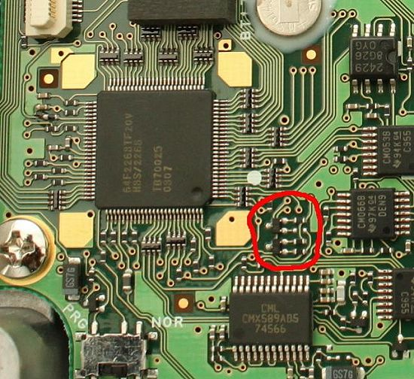
- Using a very fine solder pen with a very hot tip, carefully remove the bottom resistor. This pic shows the finished result with an arrow pointing at the removed resistor:
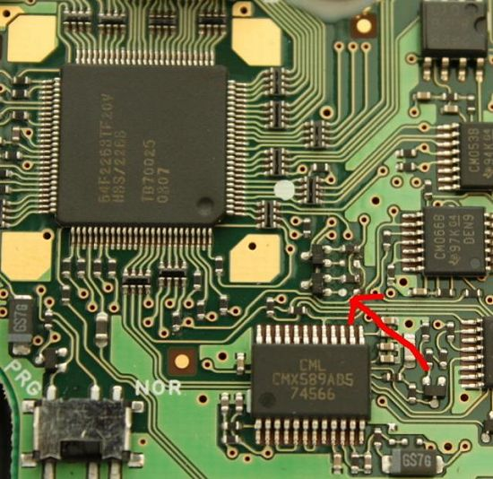
- Reassemble the radio and you're good to go.
When you first power on the radio after performing this mod, you will notice that the radio has reset itself. If it didn't, you probably need to manually reset it.
After modification, the transmit range is as follows:
136-174 Mhz
222-225 Mhz (unchanged)
420-470 Mhz

