FT-8800 TX and RX

I just recently purchased a FT8800 and could not find any mod for the freq CAP/MARS modificaton: Called Yaesu 8-22-03 and said that it would be around 2 months before it would be released.
I took the 8 screws off of the top and sides of the unit. Located the main CPU and on the left side approximately the same location as the FT8900 are 6 spaces next to the case. One Resistor/Diode at the front toward the panel and one at the rear most position toward the back of the unit.
I took it on myslef to unsolder the front as it was similar too the 8900 and left the rear one in tact.
IT WORKED; powered the unit up and it went through the entire reset like the 8900. NOTE: The resistor/diode when unsoldering I used a very low wattage soldering iron with a ground strap from the iron too the case of the radio. It works flawlessly.

Thanks to James Fairhurst for the picture.
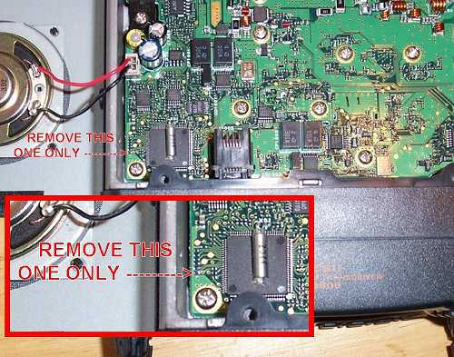
I find that after using the crossband repeat function, when switching back to normal operation, the transmit audio, on the left side, is terrible with very low power. I have to switch off the radio and switch it back on to get it to work normally. Has anyone else found this or have any ideas or suggestions.. This was on the amateur frequencies.

