FT-DX1200 YAESU

FT-DX1200
right side mods original jp 6-7 closed
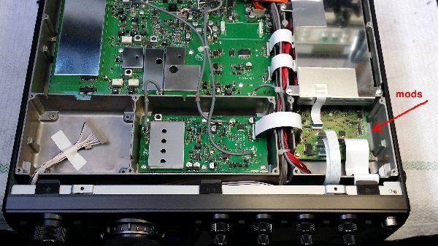

FT-DX-1200
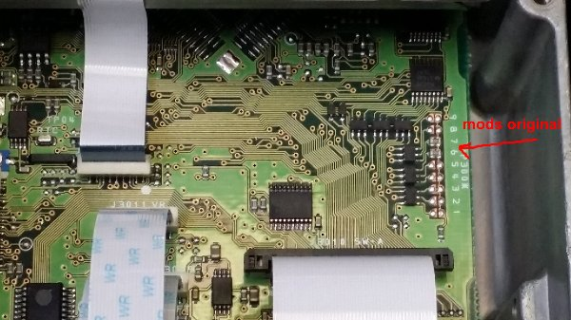
FT-DX-1200 EXTENSION BAND SOLDER JP-5
proceed rest power ON + FAST + LOCK
TX-1.8 / 30 mhz 50 / 54 mhz
